Lab 15 : Change Data Capture (CDC) with MySQL

Table of Contents
Table of Contents 2
Introduction 3
Learning Objectives 3
Prerequisites 3
Part 1 — Enable Binary Logging in MySQL 4
Step 1 — Start the MySQL Database 4
Step 2 — Create the Target Table 5
Step 3 — Create the Redpanda Topic 5
Part 2 — Write the CDC Pipeline 6
Architecture Breakdown 7
Part 3 — Execute and Trigger Changes 8
Step 1 — Start the CDC Pipeline 8
Step 2 — Make Changes in MySQL 8
Step 3 — View the CDC Stream in Redpanda 9
Knowledge Check 11
Troubleshooting 11
Symptom: this feature requires a valid Redpanda Enterprise Edition license 11
Symptom: Failed to connect to mysql: ... connection refused 11
Next Steps 12
Conclusion 12

Introduction
Much like PostgreSQL, MySQL is one of the most widely used relational databases in the world. Instead of applications double-writing to a database and a streaming topic, Change Data Capture (CDC) allows you to turn the database itself into an event stream.
In MySQL, this is achieved by reading the Binary Log (binlog). As soon as a row is INSERTED, UPDATED, or DELETED, Redpanda Connect tails the binlog and streams the exact row-level change into a Redpanda topic.
In this lab, you will configure a local MySQL database with row-level binary logging enabled and stream live database changes directly into Redpanda Serverless.

Learning Objectives
Upon completing this lab, you will be able to:
- Configure a MySQL database to support Write-Ahead Log CDC (Binary Logging).
- Understand the requirements of ROW based binlog formats.
- Use the enterprise mysql_cdc input connector in Redpanda Connect.
- Observe row-level insert and update events streaming into Redpanda.

Prerequisites
- rpk installed and authenticated to Redpanda Cloud.
- Docker installed and running.
- Your Serverless Bootstrap Server URL and credentials.
- Redpanda Enterprise License: Just like PostgreSQL CDC, the mysql_cdc component is an enterprise-only feature. You must have an active license string or a free trial from Redpanda (https://redpanda.com/try-enterprise).

Part 1 — Enable Binary Logging in MySQL
Standard MySQL configurations do not always capture the full row state required for CDC. We must explicitly enable the binary log (log-bin), set the format to ROW, and ensure full row images are captured.

Step 1 — Start the MySQL Database
We will run a MySQL container and pass the necessary CDC configuration flags directly in the startup command.
Run this command in your terminal:
docker run -d --name lab-mysql \
-e MYSQL_ROOT_PASSWORD=secret \
-e MYSQL_DATABASE=analytics \
-p 3306:3306 \
mysql:8.0 \
--server-id=1 \
--log-bin=mysql-bin \
--binlog-format=ROW \
--binlog-row-image=FULL

(Wait 10-15 seconds for the database to fully initialize before proceeding to the next step).
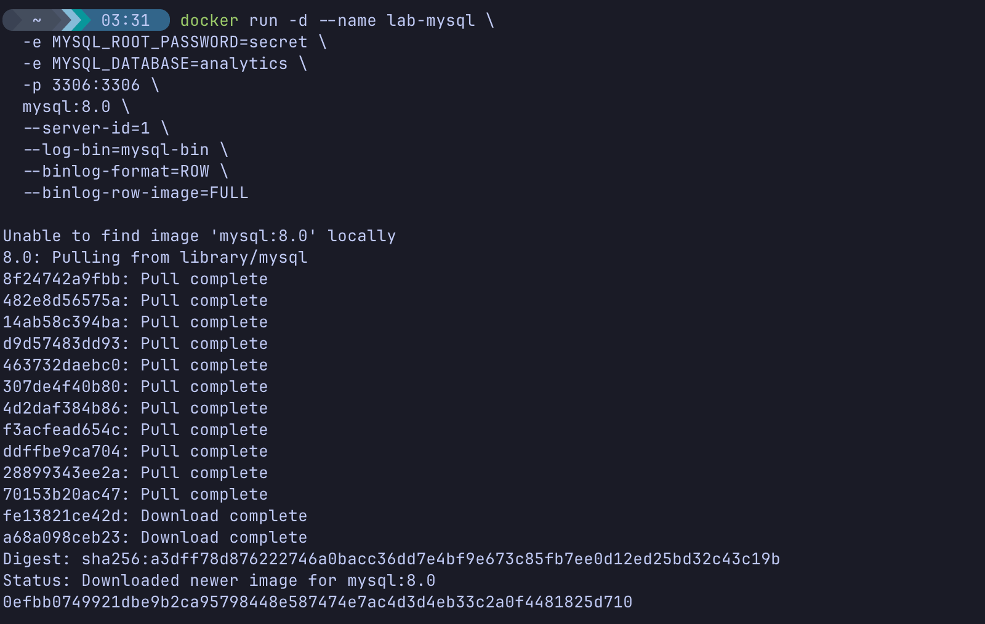

Step 2 — Create the Target Table
Now, we will create a users table inside the analytics database to monitor.
docker exec -it lab-mysql mysql -uroot -psecret -e "
USE analytics;
CREATE TABLE users (
id INT AUTO_INCREMENT PRIMARY KEY,
username VARCHAR(50) NOT NULL,
status VARCHAR(20)
);"

Step 3 — Create the Redpanda Topic
Create a new topic in Redpanda Serverless to catch the MySQL CDC events:
rpk topic create mysql-cdc-events
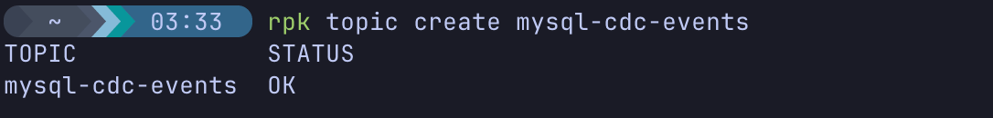

Part 2 — Write the CDC Pipeline
Navigate to your module 8 lab folder:
cd ~/rp-resilience-labs
nano mysql_cdc.yaml

Paste the following configuration. Update the Kafka output block with your Cloud credentials!
input:
mysql_cdc:
dsn: root:secret@tcp(localhost:3306)/analytics
tables: [ "users" ]
# We must explicitly tell the connector if we want to copy the existing table first
stream_snapshot: true
# Connect needs a place to store its binlog position in case it crashes
checkpoint_cache: cdc_cache

# A simple in-memory cache to store the checkpoint coordinates
cache_resources:
- label: cdc_cache
memory: {}
# We filter to only stream events from our specific table
tables: [ "analytics.users" ]
pipeline:
processors: [] # We will stream the raw CDC payload directly to see what it looks like
output:
kafka:
addresses: [ "YOUR_BOOTSTRAP_SERVER_URL:9092" ]
topic: "mysql-cdc-events"
tls: { enabled: true }
sasl:
mechanism: SCRAM-SHA-256
user: "your_username"
password: "your_password"

(Save and exit).

Architecture Breakdown
- mysql_cdc: This input connects to MySQL, masquerades as a standard MySQL replica, and requests the binary log stream.
- dsn: The standard Go MySQL connection string format (user:password@tcp(host:port)/dbname).
- stream_snapshot: Instructs the connector to fetch the current, existing data from the table first before switching over to tailing the live binlog changes.
- checkpoint_cache: Connect constantly updates a cache with its current binlog position. If the pipeline restarts, it reads this cache so it resumes exactly where it left off without duplicating data. We use a simple memory cache here, but in production, you would use a persistent cache like Redis or a file.

Part 3 — Execute and Trigger Changes

Step 1 — Start the CDC Pipeline
To use enterprise features, we must pass our license key into the Docker container using an environment variable (REDPANDA_LICENSE).
Export your license key in your terminal (if you haven't already in your current session):
export REDPANDA_LICENSE="your-long-license-string-here"

Run Redpanda Connect:
docker run --rm -it \
--network host \
-e REDPANDA_LICENSE=$REDPANDA_LICENSE \
-v $(pwd):/data \
redpandadata/connect:latest \
-c /data/mysql_cdc.yaml

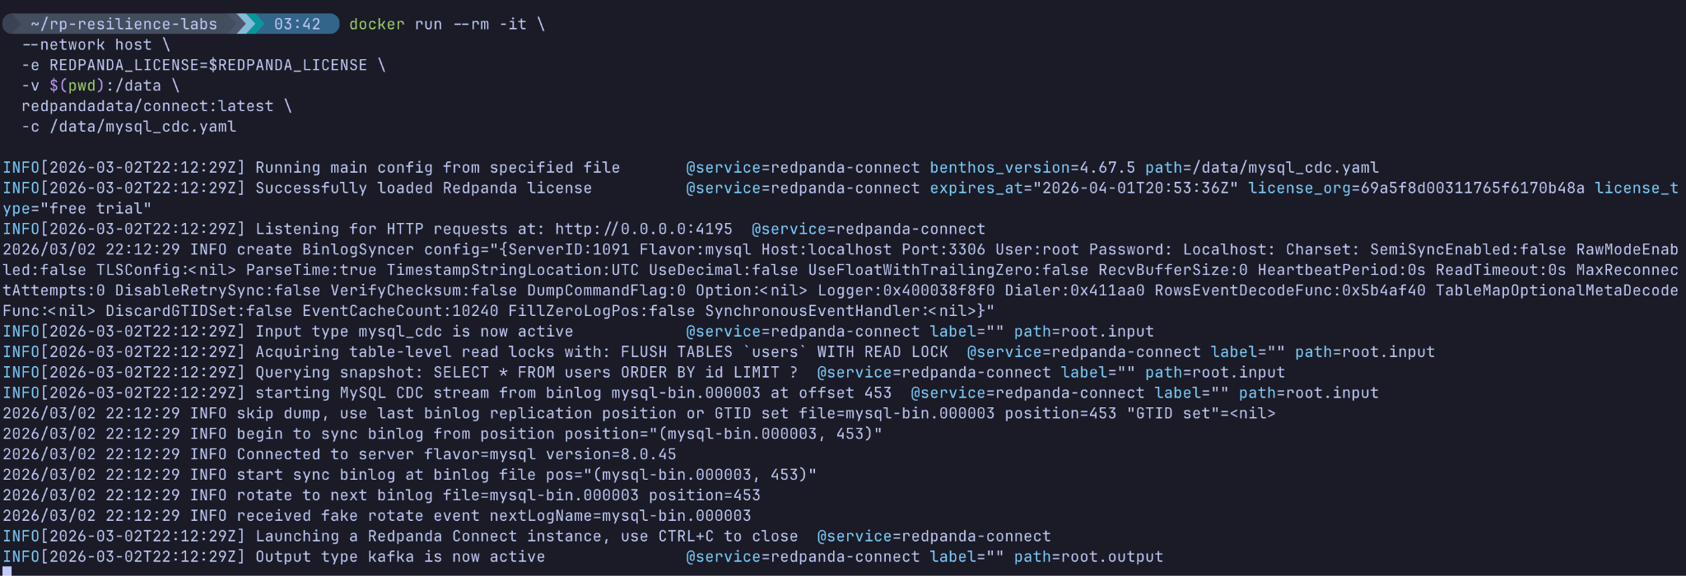
(Leave this running. It is now secretly listening to the MySQL binlog!)

Step 2 — Make Changes in MySQL
Open a second terminal window. We are going to execute standard SQL commands against our database.
Insert a row:
docker exec -it lab-mysql mysql -uroot -psecret -e "INSERT INTO analytics.users (username, status) VALUES ('alice', 'pending');"

Update that row:
docker exec -it lab-mysql mysql -uroot -psecret -e "UPDATE analytics.users SET status = 'active' WHERE username = 'alice';"

Delete the row:
docker exec -it lab-mysql mysql -uroot -psecret -e "DELETE FROM analytics.users WHERE username = 'alice';"

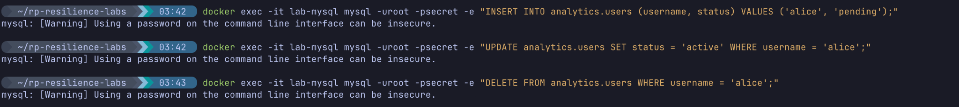

Step 3 — View the CDC Stream in Redpanda
Let's see what arrived in our Redpanda Cloud topic!
rpk topic consume mysql-cdc-events -o start

Expected Output:
You will see rich JSON payloads representing the exact database operations.
The INSERT Event:
{
"operation": "insert",
"schema": "analytics",
"table": "users",
"after": { "id": 1, "status": "pending", "username": "alice" }
}

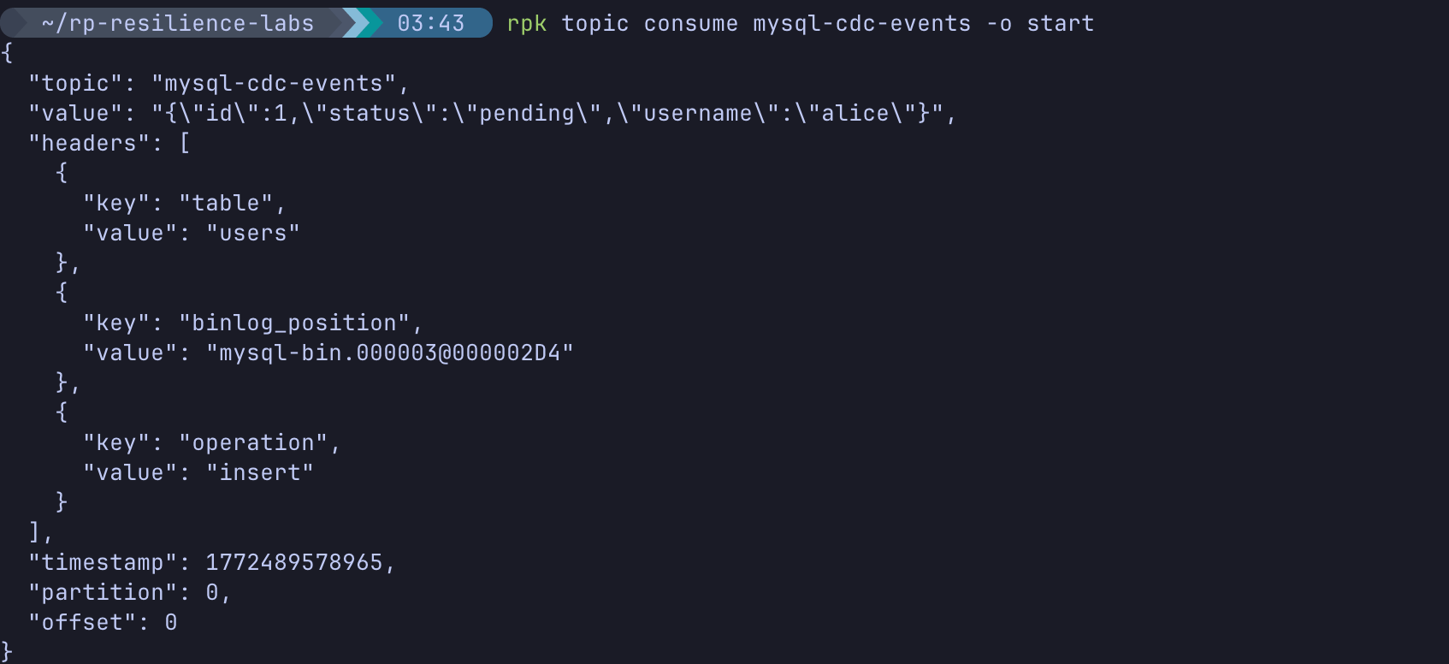
The UPDATE Event:
{
"operation": "update",
"schema": "analytics",
"table": "users",
"before": { "id": 1, "status": "pending", "username": "alice" },
"after": { "id": 1, "status": "active", "username": "alice" }
}

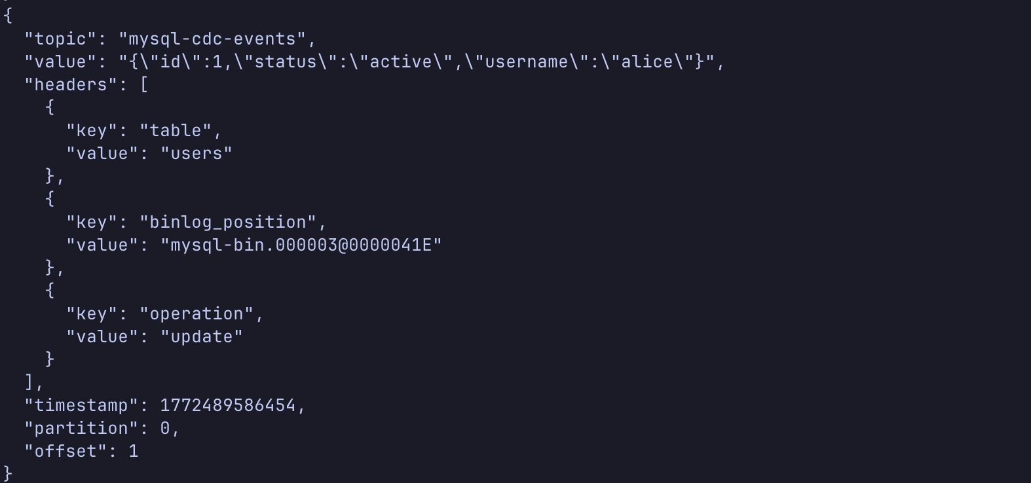
(Press Ctrl+C to exit the consumer, and stop Redpanda Connect in the first terminal).

Knowledge Check
- Why do we need to set --binlog-format=ROW in MySQL for CDC?
  - Answer: Statement-based logging only captures the exact SQL string executed (e.g., UPDATE users SET status='active'). Row-based logging captures the actual data payload before and after the change for every single row affected, which is required for accurate streaming pipelines.
- Why do we set --server-id=1 on the MySQL database?
  - Answer: MySQL replication requires every server in the replication topology to have a unique ID. Since Redpanda Connect connects as if it were a replica, the master database must have its own unique ID assigned.

Troubleshooting

Symptom: this feature requires a valid Redpanda Enterprise Edition license
Solution: You forgot to pass the license key to the Docker container, or your 14-day trial has expired. Ensure you have exported the REDPANDA_LICENSE variable and included the -e REDPANDA_LICENSE=$REDPANDA_LICENSE flag in your docker run command.

Symptom: Failed to connect to mysql: ... connection refused
Solution: The MySQL Docker container may still be initializing. Wait 10-15 seconds after running the docker run command for MySQL to fully boot up before launching Redpanda Connect. Also, ensure you used --network host in the Redpanda Connect docker command.

Next Steps
Clean up your environment:
docker stop lab-mysql
docker rm lab-mysql
rpk topic delete mysql-cdc-events

Conclusion
In this lab, you expanded your Change Data Capture toolkit to include MySQL. By enabling Binary Logging and using Redpanda Connect's enterprise mysql_cdc connector, you built an architecture capable of instantly streaming legacy relational data into your modern real-time streaming platform.

